

Weekly Newsletter – Friday 9th July – Summer 2 Term

Email: [office@stmarysinfschool.org.uk](mailto:office@stmarysinfschool.org.uk) or [office@stmarysjunior.org.uk](mailto:office@stmarysjunior.org.uk)

**Executive Headteacher, Mrs S Hulme. Chair of Governors, Mr B Tomkins**

Safeguarding Statement: This school takes notice of and adheres to all the national and local policies and guidance in regard to Safeguarding Children and Young People.

Lead Safeguarding Person Junior School: Mrs. S Hulme Nursery & Infant School: Mrs. M Quinn.

Safeguarding Deputies: Mrs. S Hulme, Mrs H Nicholls, Miss F Sullivan & Miss E Bryant Safeguarding Governor: Mr. T Richmond

Dear Parents or Carers,

Two weeks to go and still counting down….

Final arrangements are being put in place for us to announce the new class arrangements for September next week. However, as pleased as we all are to welcome new members of staff to the St Mary’s Team, we also have some farewells that make us sad, some of which means coming to the end of an era of school celebrations.

Mrs Roberts, Music Lead is leaving us after 19 years contributing to our wonderful music traditions across both the infant and junior school.  She leaves a trail of wonderful musical developments and also computing expertise. Her service and commitment to our musical success has been inspirational to all, both for the children and adults alike. We have grand memories of times in The Royal Albert Hall, The Festival Theatre and then ranging to other moments when we sang in the shopping centre to raise money at Christmas for St Raphael’s Hospice and cheered up the residents in a local home singing carols. Or just having the joy of singing our prayers day to day in school. We wish her much luck and send her off with our love as she returns to Australia to be with her family.

We also say farewell to Mrs Nicholls, Assistant Headteacher (Junior School). She is moving to take up a post as Deputy Headteacher in Surrey. Mrs Nicholls has also contributed to our musical arrangements whilst leading assessments procedures that support progress and attainment in school. Mrs Mason (Infant School) is taking a break from full time work. As Lead of RE, she has modelled diligence and dedication to our Catholic Community. We thank her for her contribution to he school and the successful RE Inspection. Miss Marlow (Infant school), PSHE Lead, will not be returning to St Mary’s following her maternity leave. Mrs Richardson will be moving to another local school, she has been maths lead and has been a champion in reviewing our whole school curriculum. Mr Carr (Juniors) is leaving us after a short 12-month contract to work closer to his home. Miss Looney (T.A. Junior School) leaves us to complete her teacher training in the next academic year. As a past pupil, we are proud of her taking this route going forward. We thank each of these staff members for their loyalty to St Mary’s community and for the wonderful work that they have done with our children, inspiring and encouraging them to aim for the stars. We ask the good Lord to bestow many blessings on them and keep watch over them as they embark on new chapters of their life. We thank them for their dedicated loyalty and service.

We have been very fortunate to have appointed some new staff from September and will notify you of these in a letter outlining the classes for next year that will be sent within the next week.

We have also welcomed back Miss Flannery in Year 3 following her recent maternity leave.

You will have been informed about the whole class bubble closures over the last couple of weeks in addition to other relevant group absences. With only a few more weeks left in school our procedures will remain in place as planned until the end of term. We are now looking forward to a new regime in September.

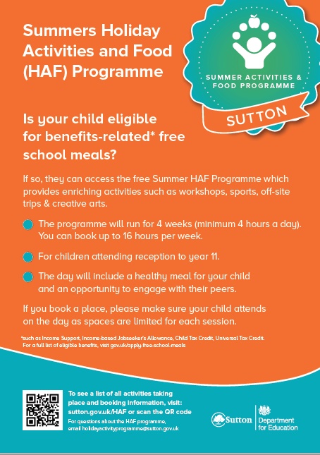

**House Points**

|  |  |
| --- | --- |
| Becket | Clitheroe |
| 956 | 910 |
| Fisher | More |
| 816 | 795 |

**Keeping children safe during community activities, after-school clubs and tuition**

This guide will help parents and carers choose a safe out of school setting for their children’ to attend. Please click on the link below

<https://assets.publishing.service.gov.uk/government/uploads/system/uploads/attachment_data/file/931508/6.6903_DFE_OOSS_Parental_Guidance_v5_ac_.pdf>

**PE Update**

It was such a shame not to get any of the junior sports days done this week due to a variety of reasons (including poor weather) but we’re going to try again next week! Please make sure your child has their full PE kit in next week and pray for good weather!   
**Nicky Birch  
PE and Clubs Coordinator  
"Developing pupils' love of physical activity, for life"**

**Early Years Request**

Dear Parents,

In Early Years we are looking to improve our continuous provision in ICT and need your help. Do you have any old mobile/home phones, keyboards, mouse’s, cameras, old programmable/remote controlled toys, walkie talkies, recordable devices, old cash machines, scales, calculators, controllers etc. around your house? We would be very grateful for any of the above to put into our provision for the children.

Thank you in advance.

**The Early Years Team**

**A present from Mrs Roberts**

As Mrs Robert’s leaving present to the school she organised a virtual assembly performance from Roger Wright who was the first 'Simba' in the West End 'The Lion King' and his guest artist Eric Appapoulay who is Cat Steven's lead guitar player. The whole school enjoyed the ‘one off’ assembly and would like to wish Mrs Roberts all the best for the future.

**Attendance**

The attendance figure for w/c 09.07.2021

|  |  |
| --- | --- |
| **Infants** | **Juniors** |
| **97.8%** | **97.4%** |
| **Our target is:** | |
| **97.4%**  **Well done** | |

**Stars of the week**

**Week Ending 9th July 2021**

|  |  |
| --- | --- |
| **R Fox Class** | **Jessica S & Sienna M** |
| **R Hedgehog Class** | **Vincent S & Giacomo M** |
| **R Squirrel Class** | **Isabella N & Isaac V** |
| **1 Robin Class** | **Anuki P** |
| **1 Sparrow Class** | **Maria C** |
| **1 Wren Class** | **Sofia D** |
| **2 Heron Class** | **Amelie S** |
| **2 Jay Class** | **Monica V** |
| **2 Woodpecker Class** | **Jan P** |



This Sunday is **SEA SUNDAY**, a day when we are invited to think very especially of seafarers and to support them with our prayers and donations. Almost 95% of what we consume in this country arrives by ship.  We are dependent upon seafarers, many of whom spent many months away from their families, to bring us what we need. The Covid-19 pandemic has brought extra challenges for this community, as it has for us all.  Please remember those at sea in your prayers this weekend.

Stella Maris is the Catholic charity which supports seafarers, fishers and their families in the UK and abroad.  To find out more about their work, click [here](https://www.stellamaris.org.uk/about-us/).



Pope Francis’ prayer intention for July is for ‘Social Friendship’.

“We pray that, in social, economic and political situations of conflict, we may be courageous and passionate architects of dialogue and friendship.”   To watch the Holy Father’s latest prayer video, click here: <https://www.youtube.com/watch?v=gjaOjJ1oqkU>

**Table Talk Topic for this week –** Are we more alive than a tree?

**Spirituality Sunday 11th July – 15th Sunday in Ordinary Time**

**Wednesday Word**

**Please click on the link below to access the weekly Wednesday Word:**

<https://www.paperturn-view.com/uk/wednesday-word/growing?pid=MTA101634&v=25.6>

**News for the week**